**MODERN DATABASE SYSTEM LAB**

**LAB2. DEVELOPING AND QUERYING MYRESTAURANTS DATA BASE**

**NAME:** PAVITHIRAN.V **ROLL.NO:**235229122

**Question 1:**

create table MyRestaurants(

name varchar(15),

foodtype varchar(10) check (foodtype= 'veg' or foodtype = 'nonveg 'or foodtype= 'chinese'),

distance number(4),

lastvisit date,

ilike number(1));

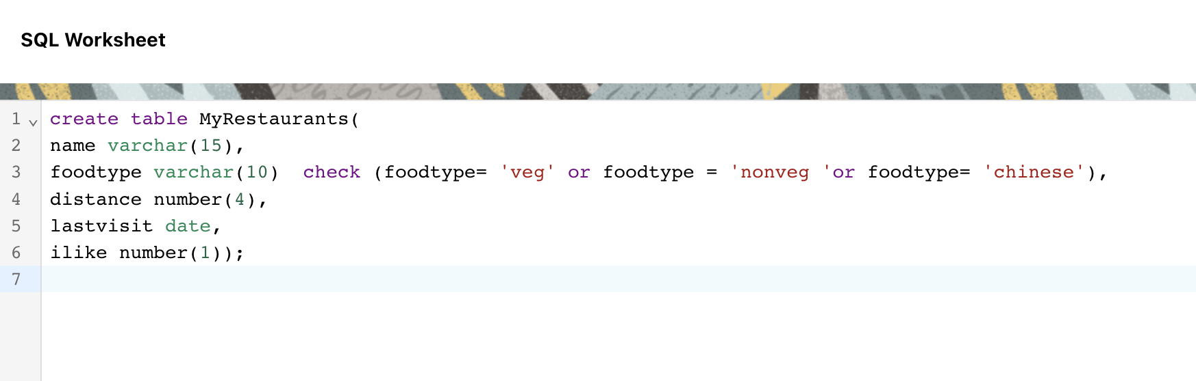

select * from myrestaurants;

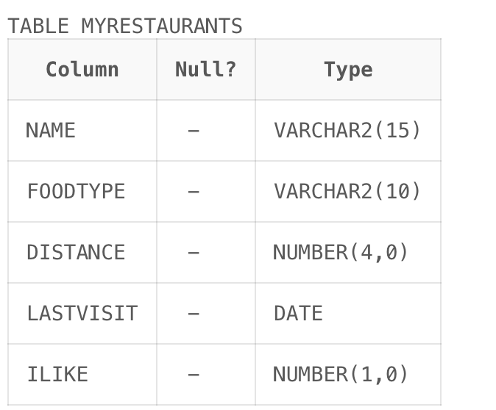

**Question 2:**

insert into myrestaurants(name, foodtype, distance, lastvisit, ilike)

values('apple_leaf','nonveg', '15', '01-Jan-2020', '1');

insert into myrestaurants(name, foodtype, distance, lastvisit, ilike)

values('sowmyas','veg', '18', '20-Mar-2020', '1');

insert into myrestaurants(name, foodtype, distance, lastvisit, ilike)

values('thinnappa','nonveg', '25', '20-Nov-2019', '0');

insert into myrestaurants(name, foodtype, distance, lastvisit, ilike)

values('sribhava','veg', '18', '20-Dec-2019', '0');

insert into myrestaurants(name, foodtype, distance, lastvisit, ilike)

values('chinaworld','chinese', '14', '05-Mar-2020', '1');

insert into myrestaurants(name, foodtype, distance, lastvisit, ilike)

values('littlechina','chinese', '30', '10-Mar-2020', '0');

insert into myrestaurants(name, foodtype, distance, lastvisit, ilike)

values('munivilas','nonveg', '20', '05-Dec-2019', '');

insert into myrestaurants(name, foodtype, distance, lastvisit, ilike)

values('dosacorner','nonveg', '10', '05-Feb-2020', '1');

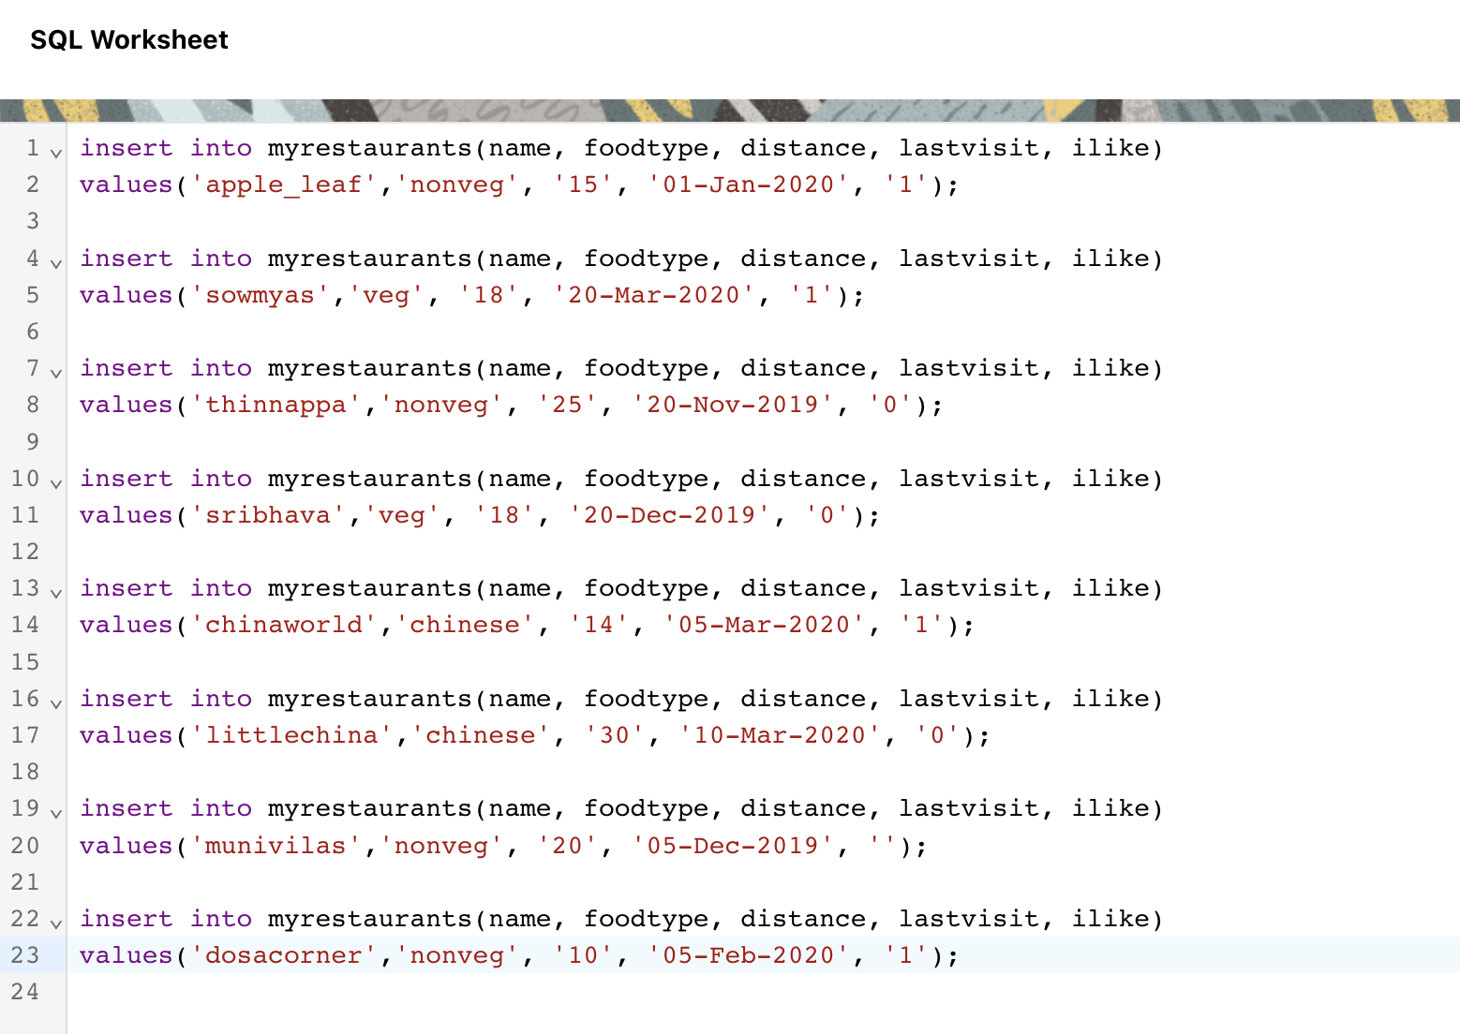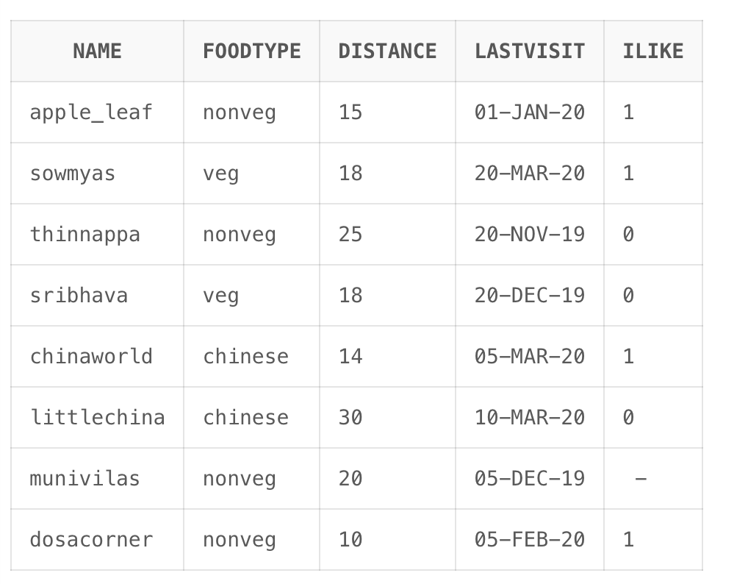

**Question 3:**

select name from myrestaurants;



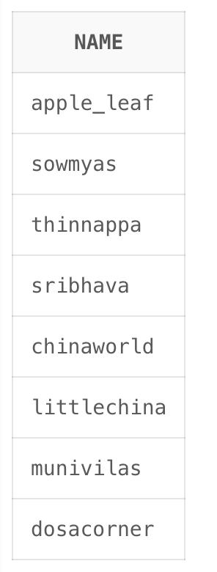

**Question 4:**

**A)**

SELECT LISTAGG(name, ',') WITHIN GROUP (ORDER BY name) AS name_list

FROM MyRestaurants;

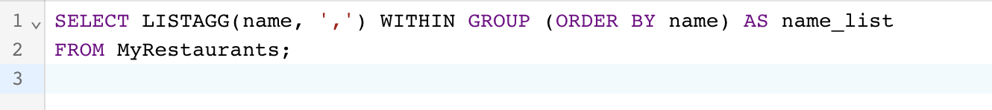

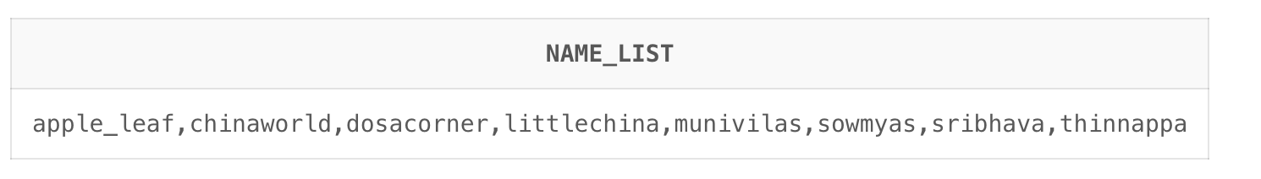

**B)**

SELECT LISTAGG(CONCAT(name, ' | '), '') WITHIN GROUP (ORDER BY name) AS name_list

FROM MyRestaurants;



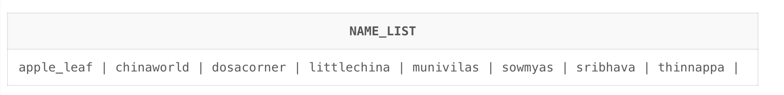

**C)**

SELECT LPAD(name, 15) AS name_formatted

FROM MyRestaurants;

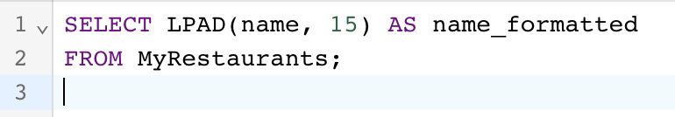

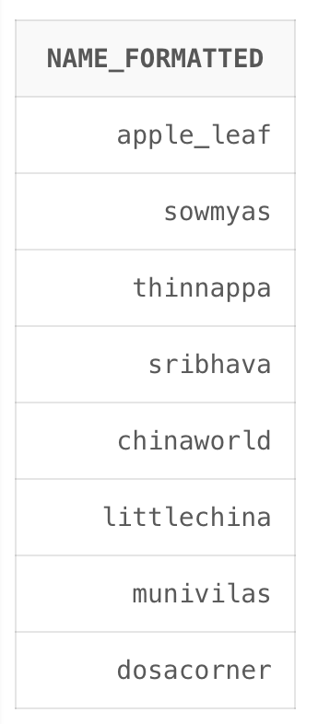

**D)**

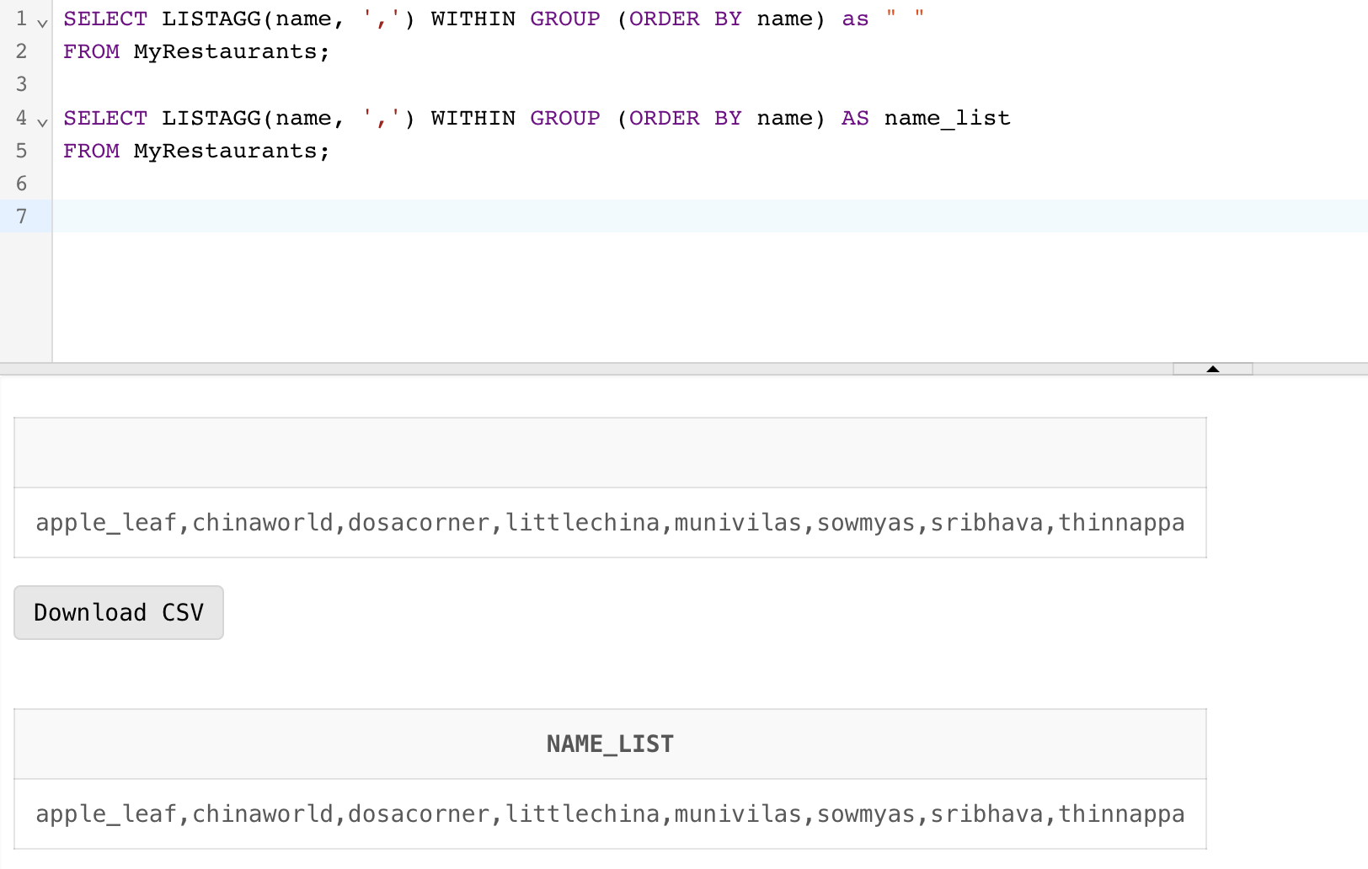

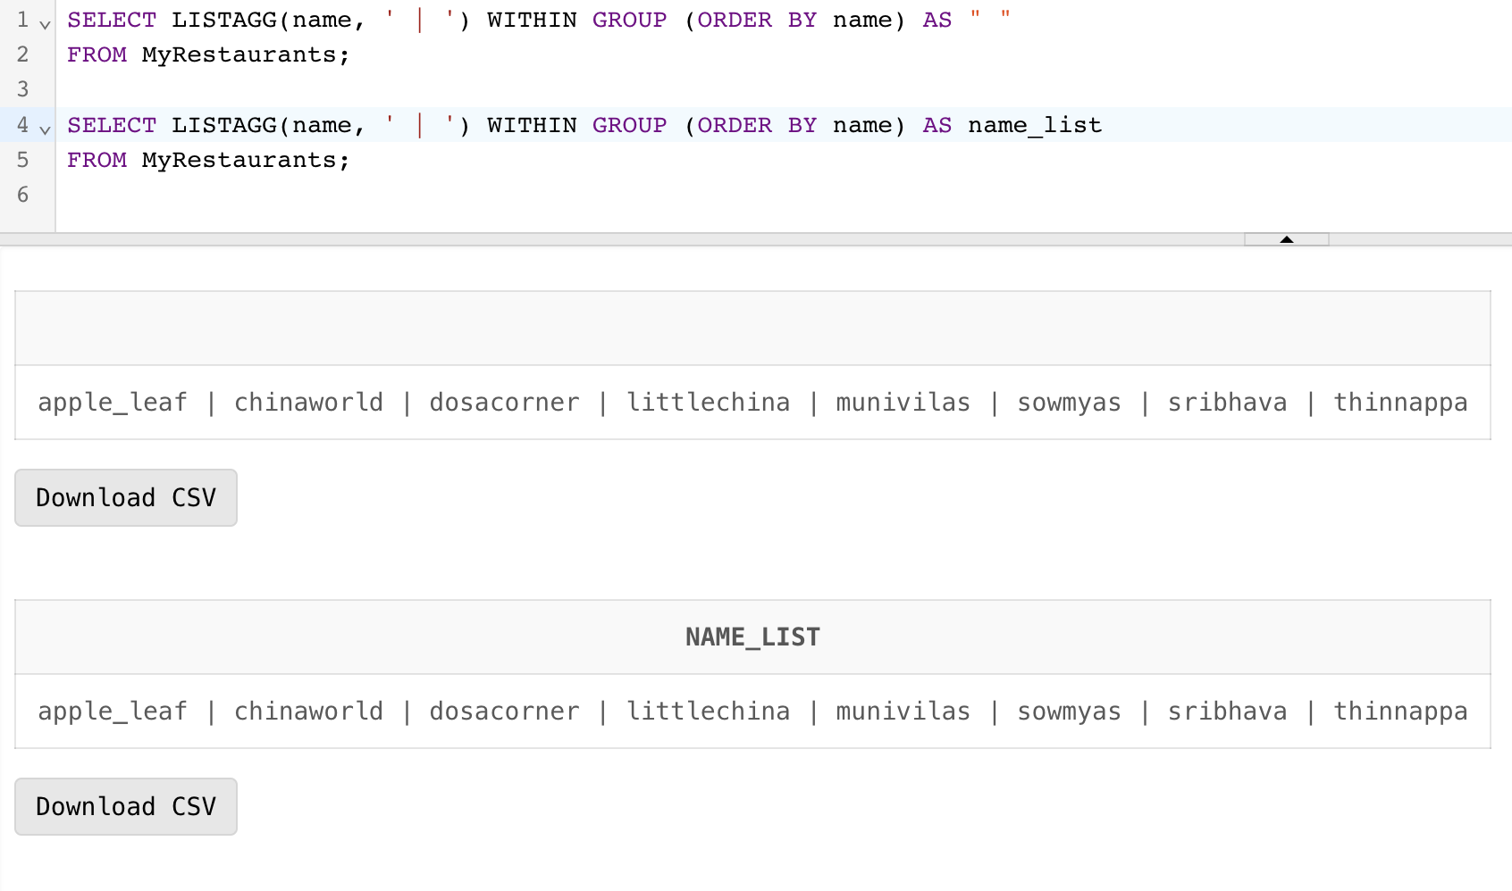

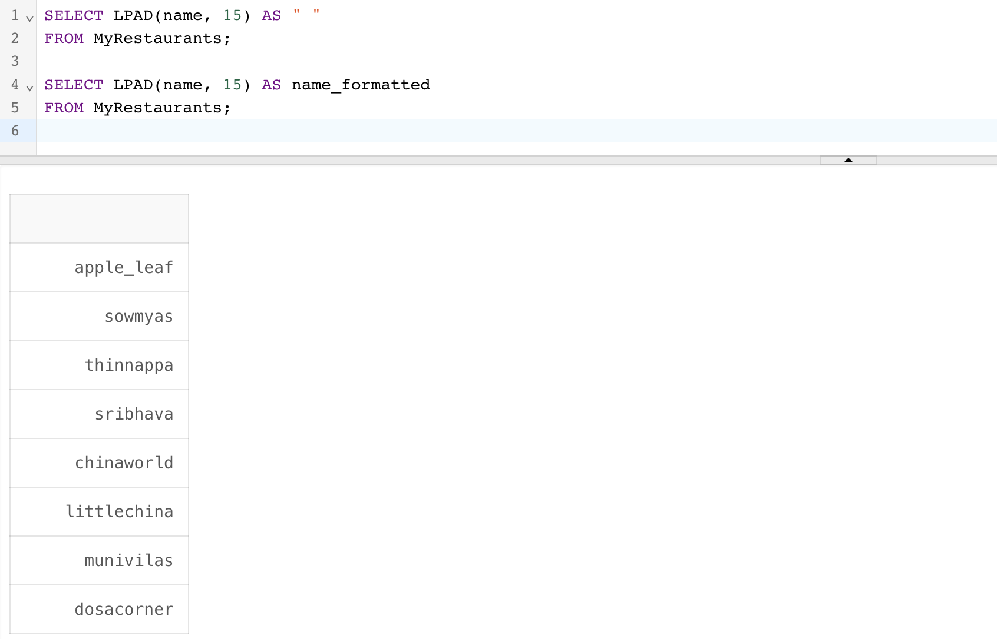

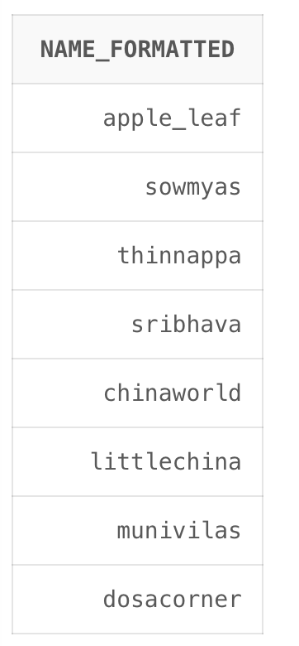

**Question 5:**

SELECT

name,

foodtype,

distance,

TO_CHAR(lastvisit, 'DD-Mon-YYYY') AS lastvisit,

CASE WHEN ilike = 1 THEN 'I LIKED IT'

WHEN ilike = 0 THEN 'I HATED IT'

ELSE 'UNKNOWN' END AS ilike_status

FROM

MyRestaurants;

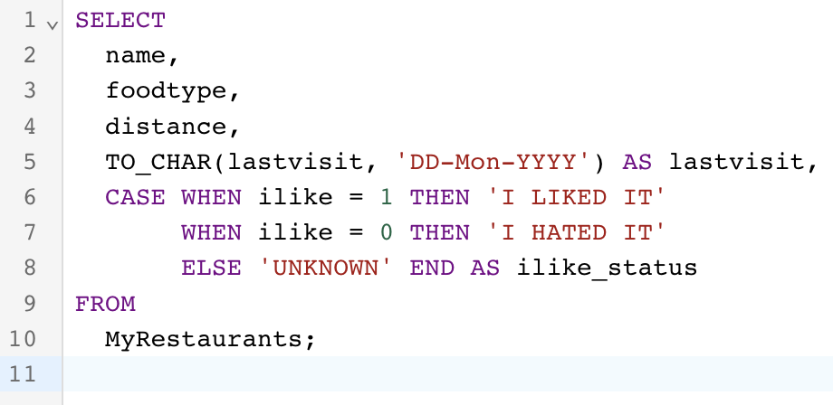

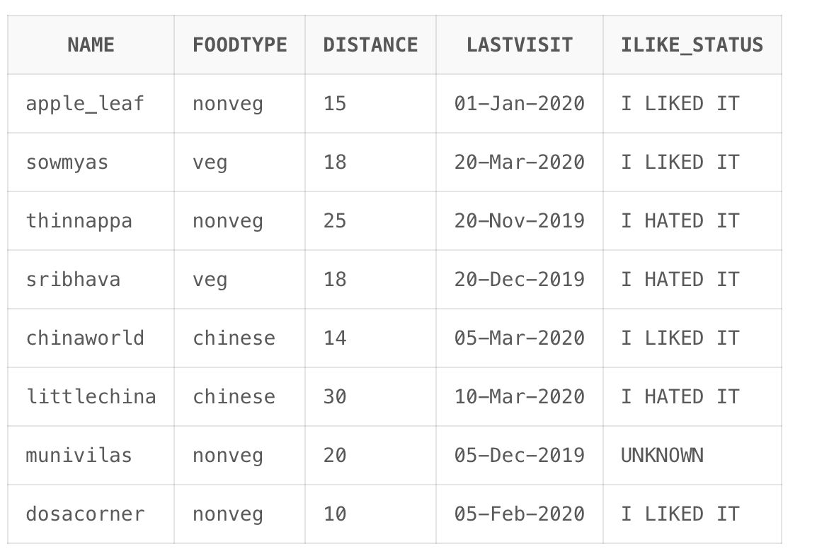

**Question 6:**

SELECT name, distance

FROM MyRestaurants

WHERE distance <= 20

ORDER BY name;

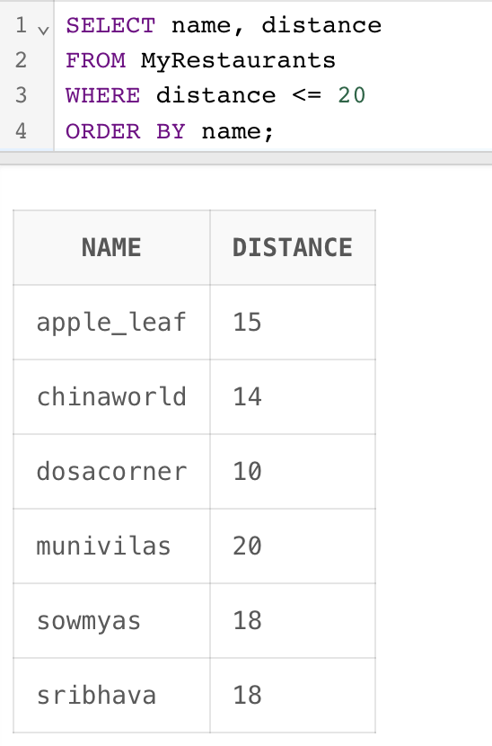

**Question 7:**

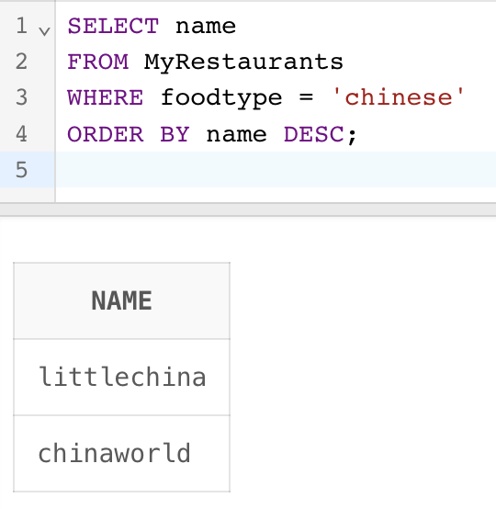

**Question 8:**

SELECT name

FROM MyRestaurants

WHERE lastvisit >= TRUNC(SYSDATE) - INTERVAL '2' MONTH

ORDER BY name ASC;

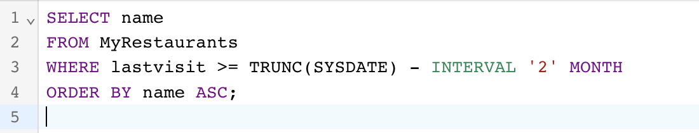

Since the dates are there in the table are too older than past 2 months there is no output

**Question 9:**

SELECT * FROM MyRestaurants

WHERE ilike = 1

AND lastvisit < TRUNC(SYSDATE) - INTERVAL '3' MONTH;

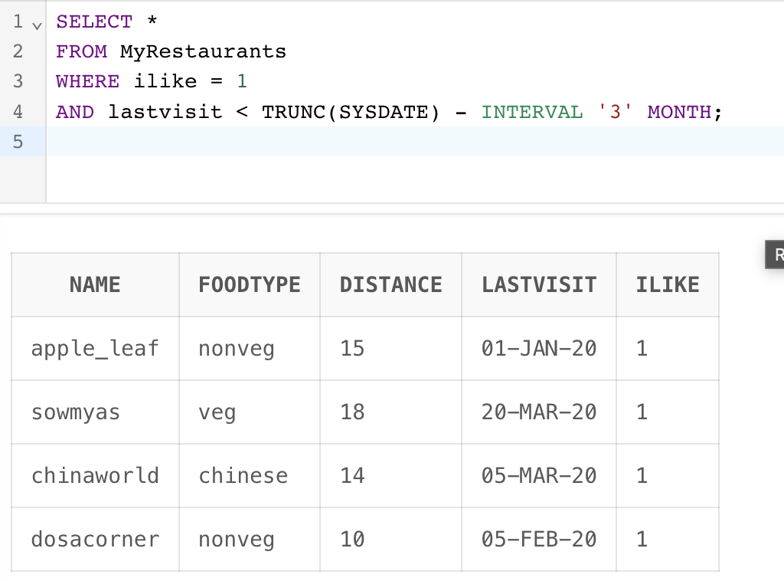

**Question 10:**

SELECT name FROM MyRestaurants

WHERE foodtype = 'chinese'

AND ilike = 1

AND distance <= 15;

